ECA5403-ELECTROMAGNETIC FILEDS AND WAVES
S.S. Manasvini
1912260424
C01-2
EXPERIMENT 6
Aim:
To write program for capacitance of parallel plate capacitor in three different dielectric medium with specific area, dielectric thickness and various dielectric constants using MATLAB.
Test case(
Determination and plotting of capacitance of parallel plate capacitor for given area and dielectric thickness
Program:
clc;
clear;
A=input("Enter the area value=");
d=input("Enter the thickness value=");
epsilon0=8.854*10^-12; C=epsilon0*A/d;
disp('The capacitance is');
disp(C);
% Plot: capacitance versus plate separation for the given area dv = linspace(1e-3,10e-3,50);
Cv = epsilon0*A./dv;
figure; plot(dv*1e3,Cv,'LineWidth',2);
grid on; xlabel('Plate separation d (mm)');
ylabel('Capacitance (F)');
title('Parallel plate capacitance versus separation');
% Validation using Laplace's equation (1-D finite-difference solution between the plates) V0 = 100;
N = 51;
V = zeros(1,N);
V(N) = V0;
for it = 1:20000 V(2:N-1) = 0.5*(V(1:N-2) + V(3:N));
% Laplace equation: d2V/dx2 = 0 end x = linspace(0,d,N);
E = -gradient(V,x);
% E = -dV/dx C_lap = epsilon0*A*abs(mean(E))/V0;
% C = Q/V0 with Q = epsilon0*E*A fprintf('Capacitance from Laplace solution = %.4e F\n', C_lap);
Output:
Enter the area value = 8e-4
Enter the thickness value = 3e-3
The capacitance is 2.36 × 10⁻¹² F
Capacitance from Laplace solution = 2.3611e-12 F
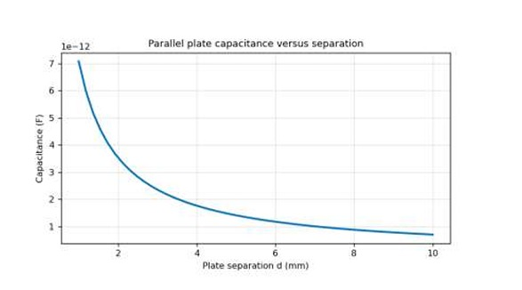
Test case
(ii) Determination of capacitance of parallel plate capacitor with three different dielectric layers
Program:
clc;
A=input("Enter the area value=");
d1=input("Enter thickness d1=");
d2=input("Enter thickness d2=");
d3=input("Enter thickness d3=");
er1=input("Enter dielectric constant er1=");
er2=input("Enter dielectric constant er2=");
er3=input("Enter dielectric constant er3=");
epsilon0=8.854e-12;
C=epsilon0*A/((d1/er1)+(d2/er2)+(d3/er3));
disp('The capacitance is');
disp(C);
OUTPUT:
Enter the area value = 8e-4
Enter thickness d1 = 1e-3
Enter thickness d2 = 3e-3
Enter thickness d3 = 2e-3
Enter dielectric constant er1 = 2.3
Enter dielectric constant er2 = 3.3
Enter dielectric constant er3 = 4
The capacitance is 3.84 × 10⁻¹² F
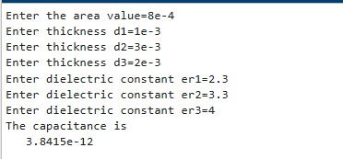
Test case (iii)
Determination and plotting of capacitance variation with dielectric constant (Air)
Program:
clc;
epsilon0 = 8.854e-12;
A = 1e-4; d = 1e-3;
er = linspace(1,1.5,100);
C = (epsilon0 .* er .* A) ./ d;
plot(er,C,'LineWidth',2);
xlabel('Dielectric constant');
ylabel('Capacitance');
title('Capacitance vs dielectric constant (Air)');
Output:
Capacitance increases linearly with dielectric constant
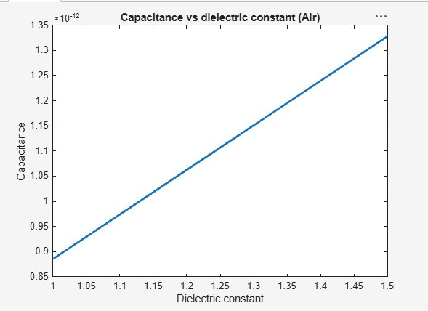

Test case (iv)
Determination and plotting of capacitance variation with dielectric constant (Glass)
clc;
epsilon0 = 8.854e-12;
A = 1e-4; d = 1e-3;
er = linspace(4,8,100);
C = (epsilon0 .* er .* A) ./ d;
plot(er,C,'LineWidth',2);
xlabel('Dielectric constant');
ylabel('Capacitance');
title('Capacitance vs dielectric constant (Glass)');
Output:
Higher dielectric → higher capacitance
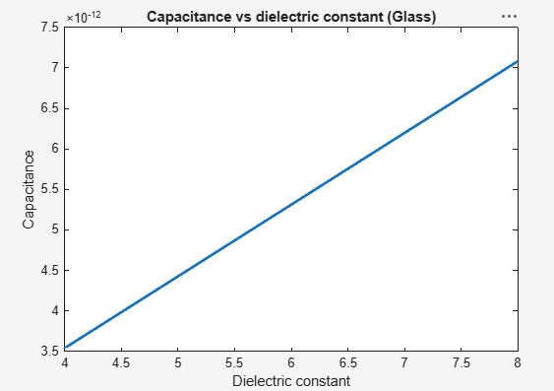
RESULTS:
Thus the program was verified for capacitance of parallel plate capacitor in different dielectric medium using MATLAB successfully.
S. No. | Objective | Assessment Criterion | Excellent – 4 | Good – 3 | Satisfactory – 2 | Needs Improvement – 1 | Weighting (%) | Marks given | Marks obtained
1 | Set capacitor geometry and material properties | Set capacitor geometry and material properties | Correctly enters plate area, separation and relative permittivity with SI units. | Inputs are correct with a minor unit/ property issue. | Several inputs need correction. | Geometry or dielectric inputs are invalid. | 25 | 2.5
2 | Calculate capacitance in MATLAB | Calculate capacitance in MATLAB | Uses the correct capacitance relation and calculates values for all specified media. | Calculations are mostly correct with minor errors. | Only some cases are calculated correctly. | Capacitance calculations are incorrect. | 25 | 2.5
3 | Compare dielectric and geometry effects | Compare dielectric and geometry effects | Correctly evaluates trends versus permittivity/area/ separation and validates the model. | Trend and validation are mostly correct with minor omissions. | Trend discussion or validation is incomplete. | Incorrectly interprets parameter effects. | 30 | 3
4 | Document engineering observations | Document engineering observations | Provides a complete table/plot with units and explains dielectric influence. | Documentation and explanation are mostly complete. | Documentation and explanation are mostly complete. | Results are incomplete or unexplained. | 20 | 2
Total |  |  |  |  |  |  | 100 | 10

